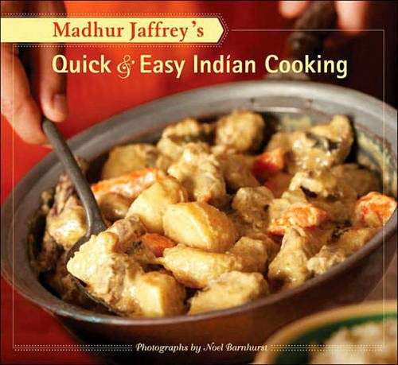

Madhur Jaffrey's Quick & Easy Indian Cooking

By Madhur Jaffrey

With more than ten reprints, it's clear cookbook author Madhur Jaffrey wins the popular vote for delicious Indian recipes that can be prepared in 30 minutes or less. Now with a beautiful new design and all-new photographs, Madhur Jaffrey's Quick & Easy Indian Cooking is ready to wow another generation of home cooks. Written by the world's foremost authority on Indian cooking, this terrific volume boasts a tantalizing array of appetizers, entres, beverages, and desserts for every occasion. From Silken Chicken and Pork Vindaloo to Fresh Red Chutney with Almonds and Sweet, Pale Orange, Mango Lassi, Quick & Easy Indian Cooking makes this exotic cuisine accessible and enjoyableas perfect for entertaining as it is for everyday cooking.

This title was selected in the New York Times list of "most-stained" favorite cookbooks from a miscellany of chefs, authors, shop and restaurant owners, stylists and bloggers.